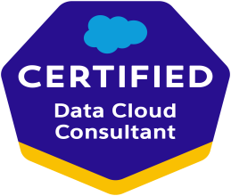
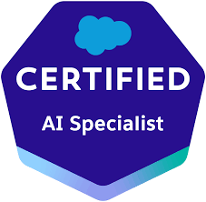
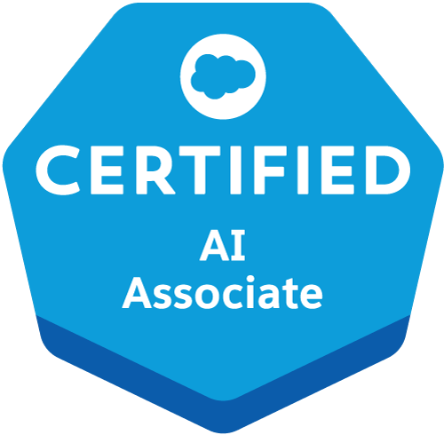
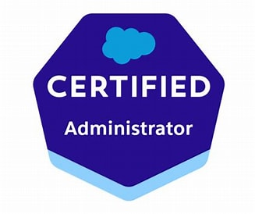
Kailash challa
Hyderabad, Telangana, India
+91-9966271277 | kailashchalla@gmail.com
linkedin.com/in/kailash-challla-shankar-3ba12b29/

Salesforce data Cloud Consultant
Salesforce Data Cloud | Advanced Data Cloud Feature Implementation | Testing Management
4x Salesforce Certified | Experienced Salesforce Data Cloud Analyst with over 4 years of expertise in Salesforce Data Cloud and 16+ years of experience in QA and Automation Testing.
Strong technology implementation experience with expertise in implementation of Data Cloud solutions |Expertise in Test Management Strategies| Skilled in API testing using SOAP and RESTful Postman | Led comprehensive test management activities |Hands-on experience in Selenium and JMETER for UI automation ,Performance Testing
Managed test allocation, coordination, and progress tracking across multiple teams
Profile Summary

- Collaborated with clients to gather and analyze requirements for Salesforce Data Cloud implementations, focusing on data unification, segmentation, and activation.
- Configured Salesforce Data Cloud features such as Data Ingestion, Data Mapping, Identity Resolution, and Calculated Insights to create unified customer profiles and actionable insights.
- Designed and implemented Data Streams and Data Lake Objects (DLOs) to enable real-time and batch data ingestion from multiple sources.
- Developed advanced Calculated Insights to generate metrics like customer lifetime value (CLV), average order value, and purchase frequency for targeted marketing strategies.
- Leveraged Data Cloud Segmentation to create dynamic customer segments based on transactional, behavioral, and demographic attributes for personalized marketing.
- Utilized Identity Resolution to unify fragmented customer data across multiple sources, creating a single, consistent customer profile.
- Enabled advanced Data Actions to trigger real-time engagement and support personalized customer journeys across multiple channels.
- Built comprehensive data models within Salesforce Data Cloud, optimizing customer data organization for easy access and analysis.
- Coordinated with cross-functional teams to implement Data Cloud solutions that drive actionable insights, improve campaign performance, and enhance customer engagement.
- Analyzed metrics from Data Cloud Dashboards to provide optimization strategies and ensure business goals are met.
- Integrated Data Cloud with Marketing Cloud to deliver personalized, multi-channel campaigns and automate customer engagement using calculated insights and real-time triggers.

Core Competencies
Project Planning & Execution | Scalable solutions leveraging Data Cloud | Marketing Communications | Campaign Strategy Development | Campaign Design & Maintenance |Data Management | Team Coordination

Technical Skills
Salesforce Data Cloud | Advanced Data Cloud Feature Implementation | CRM Cross-Functional Expertise | Unified Customer Insights | Sales |Service | Customer Relationship Management (CRM) Tools | Campaigns | Accounts &Contacts | Cases and Service Requests

Professional Experience
ETG GLOBAL SERVICES PVT LTD, HYDERABAD OCT 2024 – PRESENT

Salesforce Data Cloud Developer

Leading Data Cloud Projects:
- Led technical aspects of Salesforce Data Cloud projects, including data ingestion, identity resolution, and calculated insights for real-time analytics and customer engagement strategies.
- Designed and implemented scalable solutions leveraging Salesforce Data Cloud to address complex client requirements for data unification and segmentation.
- Configured Data Streams, Data Lake Objects (DLOs), and Data Model Objects (DMOs) to facilitate seamless data integration and unification from multiple sources.
Data Modeling and Analytics:
- Developed a comprehensive data model within Salesforce Data Cloud, structuring customer data for efficient access and analysis.
- Built and optimized Calculated Insights for metrics such as customer lifetime value, purchase frequency, and average order value, supporting personalized marketing strategies.
- Enabled real-time analytics by integrating Data Cloud APIs with downstream systems, driving actionable insights for marketing and sales teams.
Advanced Segmentation and Campaign Support:
- Created dynamic segments using Salesforce Data Cloud Segmentation Builder, targeting customers based on behaviors, demographics, and transactional data.
- Integrated Data Cloud insights with Marketing Cloud to trigger personalized campaigns, including cart and browse abandonment journeys, via API integrations.
- Implemented Data Actions to automate engagement triggers across multiple channels, enhancing customer experiences.

Academics
B.E - (Telecommunications Engineering) from Bangalore University, Karnataka, India
MBA-(Project Management) from Sikkim Mani pal University

Certifications
Salesforce Certified Data Cloud Consultant | Salesforce Certified Administrator |Salesforce AI Associate |
Salesforce AI Specialist

Projects Executed
Data Cloud Implementation Feb 2023 – Sep 2024
Client: Fire Mountain Gems and Beads

Role: Developer
- Integrated data from multiple sources to create single view of customer.
- Design and implement scalable solutions leveraging Salesforce Data Cloud to address client needs effectively.
- Provide ongoing support and maintenance for Salesforce Data Cloud implementations, including troubleshooting issues and optimizing performance.
- Design and implement a comprehensive data model within Salesforce Data Cloud to structure and organize customer data effectively, facilitating easy access and analysis.
- Merging diverse customer data sources to create a unified view in the Data Cloud, providing a comprehensive understanding of customer interactions.
- Defining dynamic customer segments based on various attributes and behaviors within Salesforce Data Cloud for targeted marketing campaigns.
- Developing sales performance insights across various time periods, including those designated for the Platinum programs, various account types, and persona or category-level segments for Marketing Cloud campaigns and journeys.
- Tracked customer interactions on website to enhance customer experience at dealership.
- Leveraged Sales Cloud and SFMC data in CDP to build campaigns like reminding customers of regular service and nudging them via email, SMS, and app to increase basket size by marketing relevant accessories using Calculated Insights.

Data Cloud Implementation Aug 2022 – Feb 2023
Client: Internal Data Cloud Accelerator
Role: Developer

- Integrated customer interactions and actions from each page of the e-commerce website using the Website Connector feature in Salesforce Data Cloud.
- Designed and implemented a comprehensive data model within Salesforce Data Cloud to effectively structure and organize customer data, ensuring easy access and analysis.
- Analyzed user interactions on the website and delivered personalized content and notifications to enhance user engagement.
- Developed complex calculated insights to identify high-value customers and provided tailored offers through personalized notifications using the Data Actions feature in Salesforce Data Cloud.
- Tracked catalog interactions of users by developing a schema and sitemap to re-engage them with targeted offers and promotions.
- Identified popular product categories across different seasons by leveraging streaming insights to optimize seasonal marketing strategies.
- Monitored inventory levels and utilized Calculated Insights and Data Actions to trigger back-in-stock and low-stock alerts, ensuring efficient inventory management.

Sales Cloud Implementation Nov 2016 – Jul 2022
Client: Quest
Role: QA Lead & Delivery Manager

- Developed comprehensive test plans, identifying risks and ensuring timely delivery of Salesforce CPQ
- Managed E2E QA/QE processes, ensuring complete test coverage across all stages.
- Expert in defect management, utilizing Azure Devops for tracking and resolution.
- Led QA teams, mentoring engineers and promoting continuous improvement. Tracked quality metrics and generated detailed reports for stakeholders. Collaborated cross-functionally with product, development, and operations teams.
- Automation of regression and smoke test suite using selenium.
- Optimized testing processes, reducing cycle times and improving efficiency. Created and executed UAT plans and designed test cases based on business needs.
- Coordinated test environments with development teams for seamless execution
- Managed a large team, including work assignment, mentoring, performance reviews, compensation and career progression

ZNALYTICSBUSINESS SOLUTIONPVT. Ltd , Dec-2015 to Oct 2016
Client: Znergy Suite
Role: Automation Test Engineer

- Played the Automation Tester role
- Understanding the User Requirements
- Preparing the Test Scenarios & Test Cases for the given requirements
- Identifying the Regressions from the prepared Test Cases
- Preparing the Automation Framework and Writing the Selenium Web Driver Scripts using java for
Regressions scenarios
- Executing the Regressions and Identifying the Defects
- Defect locking in the Defect tracking tool called Bugzilla
- Discussing about the defects with the developers
- Attend the client meetings
COVALENSE TECHNOLOGIES PVT. Ltd, | Dec July 2013 – Nov 2015
Client: AOT (www. Appointmentsontime.com)
Role: Senior QA

- Played the Sr,QA role
- Understood the complete requirements of the Client
- Preparing the Automation scripts selenium to check Functional of Application
- Involved in test scripts review and debugging of modification existing scripts.
- Preparing and Executing Batch Test Suite through TestNG.
- Verify the Automated test Result, and Logging the Defect in Mantis and creating report
- Experience in debugging and modification of existing scripts.
- Analysis of the requirement specification given by the Client
- Attending client calls & discussions understand the requirements & expectations
- Coordinating with the development team
- Test Design (Test Plan, Test Cases), Test Case Execution
- Generation of Test Reports (Daily Test Status Report, Weekly Test Status Reports, Bug Summary Reports)
- Performed Smoke testing, UI, System testing, Regression testing, and retesting.
- Reporting the defects into Mantis and reopening/ closing the same.
- Performed Smoke testing, System testing, Ad-hoc testing and Regression testing.

APERE INDIA PVT. Ltd (Acquire By Citrix) Mar 2011- June 2012
Client: Citrix Systems ( http://www.citrix-india.com/)
Role: Automation Test Engineer

Responsibilities:
- Analyzed the Business Requirements Document, created the Module level test plan and prepared detailed test cases for new Functionality
- Experience in Test Automation, Scripts Preparation and execution within the framework.
- Developed Manual test scripts for different test scenarios covering all aspects of project functionality using Selenium.
- Involved in performing GUI, Functional, System and Regression Testing.
- In the regression phase, the project was automated using Selenium. I was responsible for developing a dynamic framework which could automate all the test cases.
- Executed test cases using both manual processes and automated test tools.
- Designed and executed test cases manually and verified actual results against expected results.
- Identified and tracked defects, generated bug reports and submitted test report.
- Worked closely with developers to ensure application development meets with the user expectations.

ETISBEW PVT. Ltd Dec 2007- Feb 2011
Client: hookerfurniture.com
Role: Test Engineer

- Preparing the Test Scenarios and test cases based on business requirements.
- Participated in discussions with client regarding the project updates and status.
- Checked the Functionality of the Application with the Clint side validations.
- Testing the application against different browsers
- Preparation of Test Status and Defect Status Report on daily basis during the test execution period
- Participated in the requirement analysis with PM and Tech Architect and prepared Test plans, RTM
(Requirement Traceability Matrix) based on the PRD (Project Requirement Documents).
- Developed Test Cases with a team covering all the functional and non-functional requirements and coordinated with development teams during the project development.
- Conducted various methods of testing like black box, regression etc as per the releases and participated along with Project Manager during Beta Release to client and UAT.
- Supported the content developers for the preparation of Help manuals.

INFOASPIRE SOFTWARE SOLUTION PVT.LTD May 2006 - Nov 2007
Client: Adsglobe.com
Role: Test Engineer

- Preparing the Test Scenarios and test cases based on business requirements.
- Testing of application at module level and system level for quality of the software.
- Performed Functional, Regression and System Testing
- Checked the Functionality of the Application with the client side validations.
- Developed Load runner scripts to support long- term performance testing strategies.
- Analyze the results, identify the bottlenecks of the system and report them to development and Generate reports for internal and external use.
- Testing the application against different browsers.
- Worked closely with developers to resolve bugs.

